The Business Plan (for CAPSIM CORE)
Assignment type: Group
Due Date: March 27 (Friday - 10AM)
Weight: 10%
Expected length: 1200 words maximum (see below for specifics)
After reading through this information if you have any questions, post them in this discussion board
Purpose of Task
The purpose of the Business Plan is to describe the initial judgements your team has made in the CAPSIMCore simulation. The Business Plan communicates the direction you think your firm should take. You are attempting to showcase your judgement skills so far. It will also help us assess your approach to running the company.
Background and Expectations
You are the top management team of a company which produces sensors. You and your five rival firms each currently have an identical product portfolio, organisational structure and market share. You have been asked by your Board of Directors to provide a short Business Plan highlighting how your team will successfully steer your company over the coming years.
The Board is keen to see your thinking, so they have asked you to populate a Miro Board as your Plan. Thankfully, they have provided you with a template with 11 different frames where they have asked you questions. You are expected to use this to brainstorm (i.e. affix sticky notes in response to the prompts, and then decide which are most important). These ideas should shape your final Statement of Intent.
The Business Plan Miro Board looks like this:
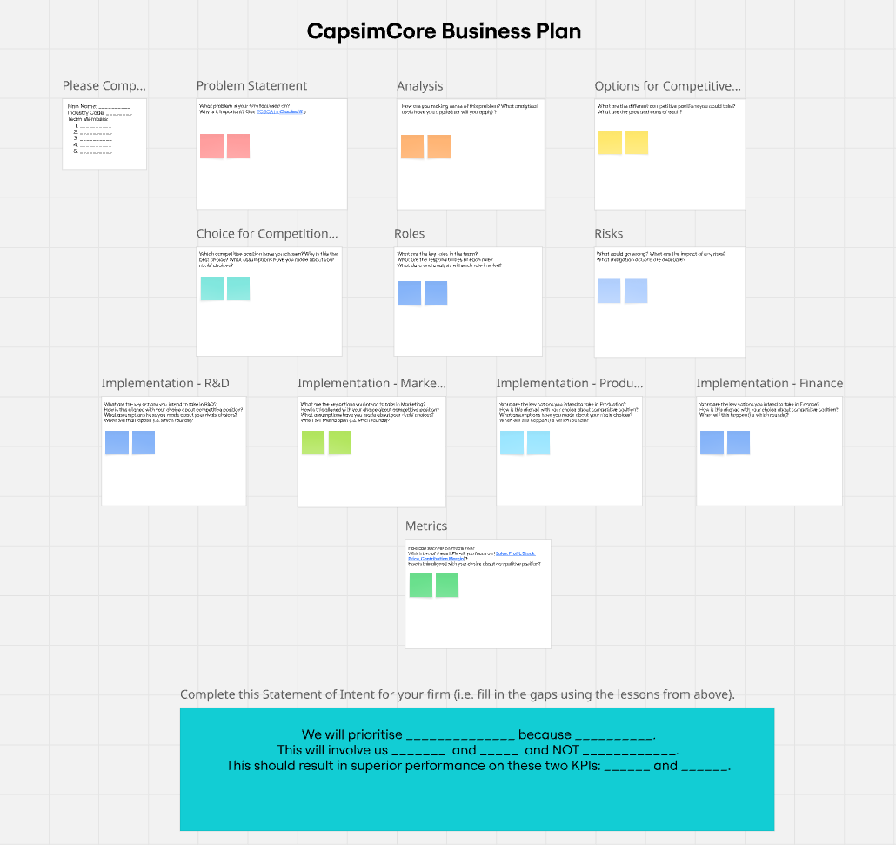
The 11 frames are:
1. Problem Statement
Please describe the big challenge/opportunity facing your firm in the sensor industry. Please attempt the TOSCA framework from Cracked It! (Chapter 4, Week 3's reading).
2. Analysis
What do you see as the most pressing problems facing your firm? How do you know this? Please show what tools/concepts are helping you make sense of this problem. Think about the tools and frameworks you have encountered in your BCom. In analysing the sensor industry and your firm, you are simply considering how it operates within the confines of the simulation. You do NOT need to research any real sensor industry. Having said that, please avoid simply describing the simulation as a game. Think about it as a simplified real world setting.
3. Options for Competitive Positioning
Please explore the choices you face in terms of a market position/competitive strategy. If you are unfamiliar with there terms, have a read through these two short articles:
Markides, C. (2004). What is strategy and how do you know if you have one? Business Strategy Review, 15(2), 5-12.
Porter, Michael E. (1996) "What is strategy?" Harvard Business Review, 74(6): 61-78.
4. Choice for Competitive Positioning
Please explicitly state your chosen intended position and the rationale(s) for this choice. Please consider the possible actions of your rivals.
5. Roles
Please share with the Board what you see as the key management tasks and responsibilities.
6. Risks
Please briefly explore your biggest worries as to what could go wrong.
7, 8, 9 & 10 Implementation across the four functional domains
Please identify and prioritise specific actions that your firm will take in pursuit of your strategy and goals in the R&D, Marketing, Production and Finance. Make sure to explain how these intended actions align with your intended competitive position.
11. Metrics
Please identify the key performance indicators (KPIs) that your company will focus on. You must select two from four parameters in the simulation, i.e., Sales, Profit, Stock Price, Contribution Margin. You must provide rationales for your choices (presumably linked to your competitive position choice).
Your Statement of Intent
Using these brainstormed judgements of your firm's situation and possible direction, please then complete the Statement of Intent. This involves filling the gaps in the final frame of the template (i.e. where you see "________" replace with your thoughts/arguments.
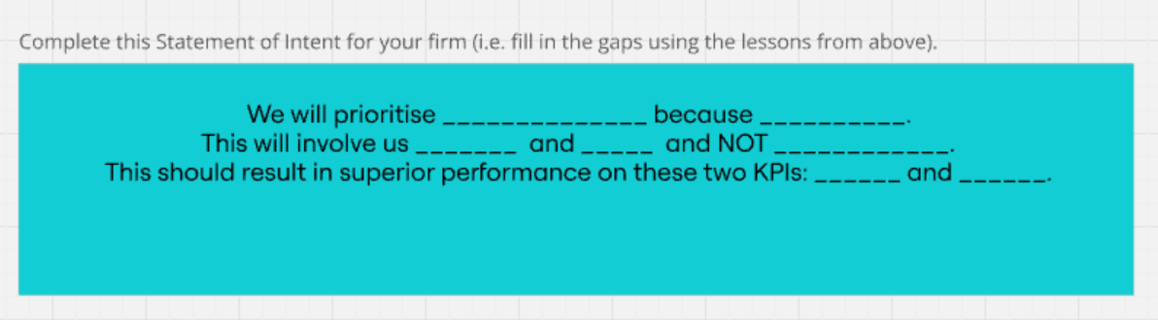
Format/Volume of content
The submitted plan must have no more than 40 sticky notes in total across the 11 frames. There must be at least one note in each frame. The content of each note must not exceed 30 words (so probably no more than two sentences). Please write full sentences (so the Board would know what you mean). The Statement of Intent should not exceed 50 words (including the words already there).

